CO2-AT2
NAME:S.JAYASHREE
REG NO:192471041
Create a generic class Repository<T, ID> that stores entities by identifier. Define operations, constraints and error handling, and explain how the design improves reusability. [Create]
Experiment: Generic Repository Using Java Generics
Aim
To create a generic class Repository<T, ID> that stores entities using an identifier, supports basic operations such as add, find, remove, and display, and demonstrates how generics improve code reusability and type safety.

Pseudocode
START

Create a generic class Repository<T, ID>.

Create a HashMap<ID, T> to store entities.

Define methods:
add(id, entity)
find(id)
remove(id)
display()

Create an Employee class.

Create a Repository<Employee, Integer> object.

Add employee records.

Display all records.

Search for an employee by ID.

Remove an employee.

Display remaining records.

STOP

Program
import java.util.HashMap;
import java.util.Map;

// Generic Repository Class
class Repository<T, ID> {
private Map<ID, T> data = new HashMap<>();

public void add(ID id, T entity) {
if (data.containsKey(id)) {
System.out.println("Error: ID already exists.");
} else {
data.put(id, entity);
System.out.println("Entity added successfully.");
}
}

public T find(ID id) {
return data.get(id);
}

public void remove(ID id) {
if (data.remove(id) != null) {
System.out.println("Entity removed successfully.");
} else {
System.out.println("Error: ID not found.");
}
}

public void display() {
if (data.isEmpty()) {
System.out.println("Repository is empty.");
} else {
for (Map.Entry<ID, T> entry : data.entrySet()) {
System.out.println("ID: " + entry.getKey() +
" -> " + entry.getValue());
}
}
}
}

// Entity Class
class Employee {
private int id;
private String name;

Employee(int id, String name) {
this.id = id;
this.name = name;
}

public String toString() {
return "Employee [ID=" + id + ", Name=" + name + "]";
}
}

// Main Class
public class Main {
public static void main(String[] args) {

Repository<Employee, Integer> repo = new Repository<>();

repo.add(101, new Employee(101, "Alice"));
repo.add(102, new Employee(102, "Bob"));

System.out.println("\nRepository Contents:");
repo.display();

System.out.println("\nSearching ID 101:");
System.out.println(repo.find(101));

System.out.println("\nRemoving ID 102:");
repo.remove(102);

System.out.println("\nRepository After Removal:");
repo.display();
}
}

Output
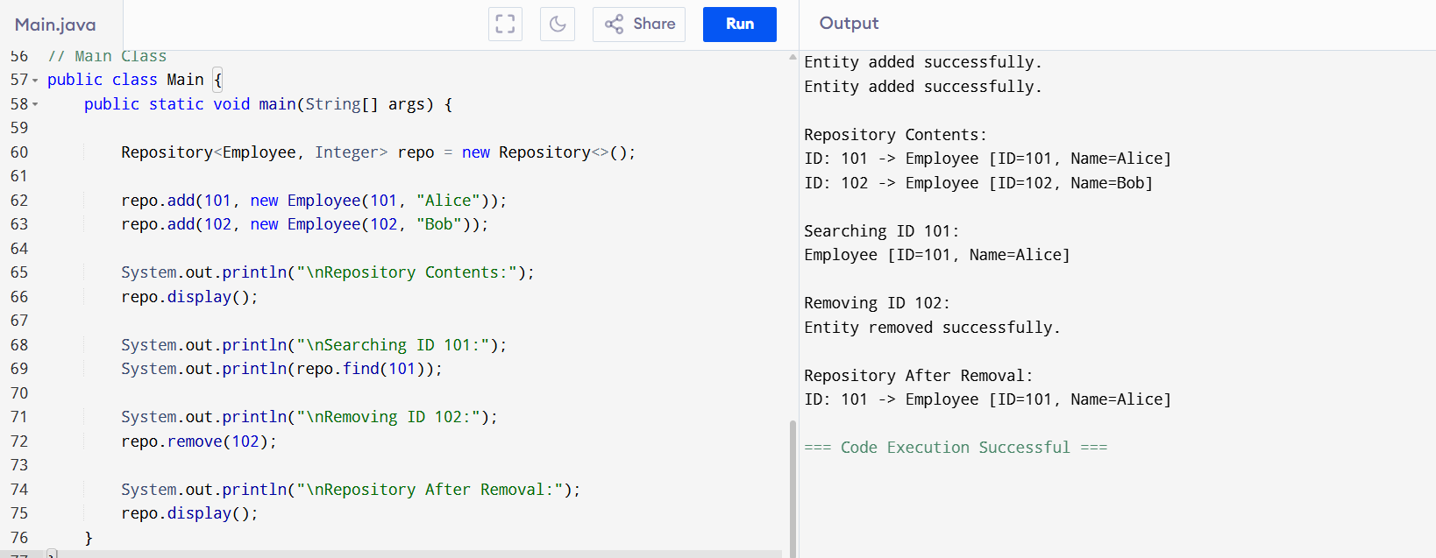
Result
Thus, the generic Repository<T, ID> class was successfully implemented. It provides type safety, code reusability, and compile-time error checking, while allowing different entity types and identifier types to be managed using the same repository implementation.

